Assignment1: The Memory Hierarchy Simulator

Yu Wang, University of Ottawa, 6852088, Email:ambitionwang@gmail.com
Part I
The Memory Hierarchy consists of several levels of memory, for example cache , main memory, disk. There more nearer the memory is to CPU, the rapider access it has. But It is much smaller. In this simulator, we only implement the cache and memory. This cache is CPU cache, which is a small area of fast memory used by the central processing unit to reduce the average time to access the main memory. The cache stores copies of most frequently used data blocks in the main memory. In this simulator, the central processing unit makes read requests to the memory. If the required data block is located in this cache, the data block will be returned directly to the central processing unit after the time of cache access. If not, the cache will access the memory for the data block. The data will be returned to the cache by the memory for the time of memory access. And the cache control will discard the least used item and store the new data block. So, if the requested data block in the cache, the access time is 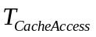. And if not, the access time is 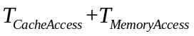. A DEVS model called “Memory Hierarchy Simulator” is created to simulate the behavior of the Memory Hierarchy.
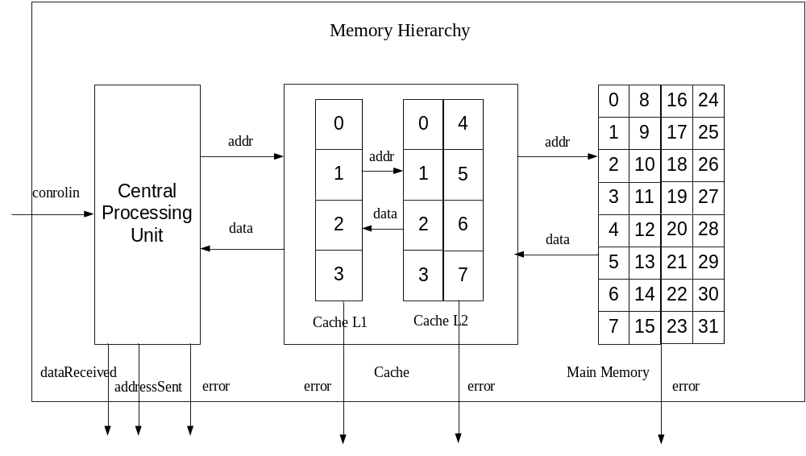
Fig1 the structure of the Memory Hierarchy Simulator
The Memory Hierarchy (MH) Simulator consists of 3 components: central processing unit(cpu), cache, main memory. The central processing unit make data request, which addresses range from 0 to 32. All data it requested are in the main memory, which has 32 data item slots. The cache consists of Cache L1 and Cache L2. Cache L1 has 4 data item slots while Cache L2 has 8 data item slots. Initially, the cache is void. Once the central processing unit makes the first data request, then cache miss occurs. Firstly, there is a Cache L1 miss, because there is no data in the cache L1. The Cache L1 will access the Cache L2. It also has cache miss. Then Cache L2 has to access the main memory to get the data. The data will be returned by the main memory and stored in the cache L1 and L2. Also, if the cache is full, then the returned data item will replace the least used data item in both cache L1 and cache L2.
The behavior of central processing unit is to generate the data address. When the central processing unit receive the data and a random time interval has passed, the unit could issue the next address. The issued address is assumed be from 0 to 31.
The behavior of cache is processing the request. If the requested data is in the cache, the cache will return the data after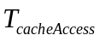. If the data is not in the cache, the cache will make a request to the main memory. After the data item is returned, the cache will select the slot for the missed data item using the least recently used method, which is described in the first paragraph.
The main memory is more simpler than the cache. Because all the requested data are in the main memory, the main memory just returns the requested data after .
Assume that the access time of Cache L1, Cache L2, main memory is 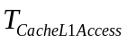,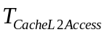,. We can analyze the time behavior of the access. There are three cases, which is showed below.
- The data is in the cache L1. So the data the cpu requested will be returned after .
- The data is in the cache L2 not in the cache L1. So the data the cpu requested will be returned after +.
- The data is only in the main memory. So the data the cpu requested will be returned after ++.
In Fig1, we can see there are several error output. When the data requested are not returned after a defined time, the error will occur. In our case, we only access the data whose addresses range from 0 to 31. There will be no error output. But in our atomic test case, we can issue a special address, then the error will occur. The controlIn signal indicates that the cpu has to finish how many memory accesses.

Part II

Formal Specifications
The formal specifications <S, X, Y, δint, δext, λ, ta> for the atomic models are defined as follows:
CentralProcessingUnit
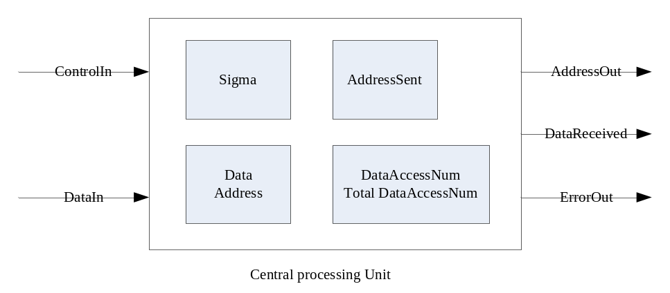
State Variables:
sigma,phase=passive
DataAccessNum; // record the issued data request index. When the data returns, the index increment.
TotalDataAccessNum //the total data request times.
AddressSending // indicating that now cpu has sent the address
Data // the state store the received data
Address // the address we want to access
DataWaitingTime // When we received the data, after a random time, we send another data access
DataTimingOut // Beyond this time, the cpu will stop working and set the errorFlag
SendingPreparationTime // After the data has arrived, the cpu will take SendingPreparationTime to issue the next request.
errorFlag // when the data doesn’t return ather DataTimingOut, this variable will be set.
DataReceivedFlag // indicating that we have received the data
Transfertimes // this variable used for errorFlag

X={ControlIn,DataIn}
Y={AddressOut, ErrorOut, DataReceivedTime}

δext (in, ControlIn, DataIn, e)
{
Case Phase
Passive:
If x from ControlIn
DataAccessNum = 0; //
TotalDataAccessNum = controlIn
AddressSending=false
Sigma=0 triger the internal function instantly
Phase=active
Else
Do nothing
Active:
If x from controlIn
Do nothing
If x from DataIn && AddressSending
Sigma=0
DataAccessNum++;
AddressSending=false ;
Data=DataIn;
Transfertimes=0
Else
Do nothing
}

δint ()
{
Case phase
active:
if( ErrorFlag )
{
Phase=passive
}
else if( ( DataReceivedFlag || !DataAccessNum ) && (DataAccessNum < TotalDataAccessNum) && !AddressSending ) // for address sending
{
Address = rand() % 32;
DataReceivedFlag = 0;
AddressSending = 1;
transfertimes = 1;
sigma= a random time interval
}
else if( AddressSending && (transfertimes == 1))
{ // for datawaiting
AddressSending = 0;
transfertimes++;
sigma= DataTimingOutTime
}
else if(AddressSending && !DataReceivedFlag)
{ //for timing out error
ErrorFlag=1;
AddressSending=0;
Sigma=0;
}
else if( DataAccessNum >= TotalDataAccessNum )
{ //finishing memory accessing
this->passivate();
}
Passive:
Nothing
}
λ(active)
{
if( ErrorFlag )
output the errorFlag to the errorport
if( AddressSending && transfertimes==1 )
{
Output the address to the addressout port
}
else if( DataReceivedFlag )
{
Output the data to the datareceived port
}
}

Cache
The difference between Cache L1 and Cache L2 is the data item slot. Cache L1 has 4 slots while Cache L2 has 8 slots. Then we give the formal specifications of Cache L1. Cache L2 has the similar definitions.
State Variables:
sigma, phase = Passive;
Miss // describe the cache miss
Hit // describe the cache hit
Address, Data // store the corresponding data and address
CacheAccessingTime //
CacheTimingOutTime // If the cache don’t receive the data in the time interval, then a error will occur.
Int CacheAddress[4] //store the data address
Int CacheData[4] // store the cache data corresponding the data address
Int counter[4] // the counter records access times corresponding the corresponding data address.
X={AddressIn, DataIn}
Y={AddressOut, DataOut, ErrorOut}
δext (in, AddressIn , DataIn, e)
{
Case Phase
Passive:
If x from AddressIn and x in the the address array
Phase=active
Sigma = CacheAccessingTime
Hit=true
Cacheindex = the index whose cacheAddressValue equals the AddressIn
Data=CacheData[Cacheindex]
Counter[Cacheindex]++
Else if x from AddressIn and x not in the address array
Phase = active
Sigma=CacheAccessingTime
Miss=true
AddressSent=1
Address= AddressIn
Else
Do nothing
Active：
If x from DataIn and Miss== true
tmpCacheIndex = the index whose value has the minimum counter record, if there are multiple choices, we randomly select one.
Data=DataIn
CacheAddress[tmpCacheIndex]= Address
CacheData[tmpCacheIndex]=DataIn
Counter[tmpCacheIndex]=0
Hit= ture
Miss=false
sigma=0
else
Do nothing
}
δint ()
{
if(ErrorFlag)
{
Phase=passive
}
else if(hit)
{
hit=false;
Phase=passive
}
else if(miss && AddressSent==1)
{
AddressSent++;
Sigma= CacheTimingOutTime
}
else if(miss && AddressSent !=1 )
{
ErrorFlag=1;
Sigma=0;
}
}
λ(active)
{
if(ErrorFlag)
port the error to the errorport
If(Hit== true)
Port the data to DataOut
If (Miss==ture&& AddressSent==1)
Port the address to Dataout
}

Main Memory
S={passive, active, int memory_array[32]}
X={in}, in=0,1,……31

Y={out, errorout} // we assume we only store integers in the memory array
δint (active) = passive
δext (in, passive) = active
δext (in, active) = active // if we receive a data request when the phase equal active, we reject the data request, which means that the main memory doesn’t support concurrent access.
λ(active)
{ send memory_array[in] to port out }
ta(passive) = INFINITY
ta(active) = main memory access time
If the received address is not in [0,31], a error will be produced.
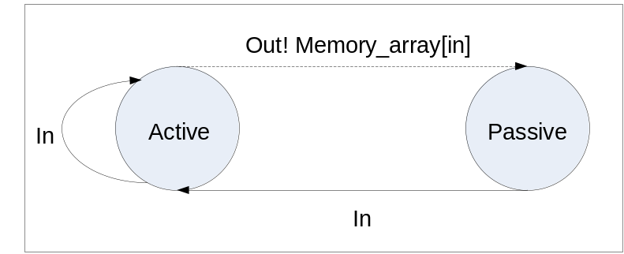
The formal specifications <X, Y, D, {M_{i}}, EIC, EOC, IC, SELECT > for the coupled model cache and lru Simulator are defined as follows:
Cache :
X = { cpuaddressin, mainmemorydatain};
Y = { cachedataout, cacheaddressout};
D = {cachel1, cachel2};
EIC={ ((self,cpuaddressin),(cachel1,addressin)), ((self, mainmemorydatain),(cachel2, datain)) }
EOC={ ((cachel1, dataout), (self,cachedataout)), ((cachel2, addressout) ,(self, cacheaddressout)) }
IC={((cachel1, addressout), (cache2 , addressin)), ((cachel2, dataout) ,( cachel1, datain))}
SELECT: ({cachel1, cachel2}) = cachel1;

LRU Simulator:
X = {controlIn};
Y = {addressout, datareceived};
D = {CentralProcessingUnit, Cache, MainMemory};
EIC={ ((self, controlIn),( CentralProcessingUnit, controlIn)) }
EOC={ ((CentralProcessingUnit, addressout), (self, addressout)), ((CentralProcessingUnit, datareceived) ,(self, datareceived)) }
IC={(( cache, cachedataout), (centralprocessingunit , datain)), ((cache, addressout) ,( centralprocessingunit, addressin)) , ((cache, cacheaddressout) ,( mainmemory, in)) , ((mainmemory, out) ,( cache, mainmemorydatain))}
SELECT: ({CentralProcessingUnit , Cache, MainMemory}) = CentralProcessingUnit;
({Cache, MainMemory }) = Cache;

Part III
In order to verify the atomic models and coupled models, test cases are created to test these models.
Test Cases and Execution Analysis
Atomic Model MainMemory:
The input of the main memory is the data address, which is expected to be from 0 to 31. If not in this scope, the main memory will output an error. The output of the main memory is the data stored in the main memory corresponding the input address. The initial value for memory address is 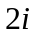. We just assume this for simplicity. The accessing time of the main memory is 40ms. When the main memory is returning the data, if there is another data access request, the main memory will neglect. The mainmemory.ev file is created as follows.

00:00:10:00 in 0
00:00:30:00 in 1 // the main memory neglects this request, for it is outputting the data whose address is 0.
00:00:60:00 in 2
00:02:10:00 in 4
00:02:50:00 in 16 // the main memory neglects this request, for it is outputting the data whose address is 16.
00:02:55:00 in 16
00:03:40:00 in 40 // the main memory will output an error. When error occur, the main memory won’t work.
00:04:40:00 in 2
The output file receiver.out shows the expected results.
00:00:50:000 out 0
00:01:40:000 out 4
00:02:50:000 out 8
00:03:35:000 out 32
00:04:20:000 errorout 1

Atomic Model Cache L1：
The input of Cache L1 is the address which is provided by the cpu, and the data which is returned by the Cache L2, if there is a cache miss in the Cache L1. If Cache L1 receives the data returned by cache L2, then the cache will update its contents and output this result immediately. If there is a miss in the Cache L1, the cache will output the address to Cache L2. The accessing time of Cache L1 is 10ms. The timing out time of cache L1 is 1s10ms. When the data is not returned back in this time interval, an error will occur.

The cachel1.ev file is created as follows.
00:00:10:00 AddressIn 10 // there is a cache miss. After 10ms, the address is issued.
00:00:30:00 DataIn 20 // data is returned and outputted immediately.
00:00:35:00 DataIn 25 //neglect this data in.
00:00:40:00 AddressIn 2 // cache miss
00:00:55:00 DataIn 12
00:01:00:00 AddressIn 4 // cache miss
00:01:15:00 DataIn 8
00:01:20:00 AddressIn 6 //cache miss
00:01:35:00 DataIn 10
00:01:40:00 AddressIn 20 //cache miss, there will a lru replacement.
00:01:55:00 AddressIn 10 // neglect this address, for the last address is not serviced.
00:02:10:00 DataIn 10
00:02:15:00 AddressIn 2 // cache hit
00:02:35:00 DataIn 12
00:02:45:00 AddressIn 10 // this item is replaced by last cache miss
00:03:00:00 DataIn 20
The output file cachel1Ma.out shows the expected results.
00:00:20:000 addressout 10
00:00:30:000 dataout 20
00:00:50:000 addressout 2
00:00:55:000 dataout 12
00:01:10:000 addressout 4
00:01:15:000 dataout 8
00:01:30:000 addressout 6
00:01:35:000 dataout 10
00:01:50:000 addressout 20
00:02:10:000 dataout 10
00:02:25:000 dataout 12 // we hit the cache
00:02:55:000 addressout 10
00:03:00:000 dataout 20

Coupled Model Cache ：
The cache model consists of Cache L1 and Cache L2. The Cache L2 has the similar structure as Cache L1 except that Cache L2 has eight data item slots. So we don’t make specific tests for Cache L2. The test file for Cache L1 also works for Cache L2. The accessing time of Cache L2 is 20ms. The timing out time of cache L2 is 50ms. We combine the Cache L1 and Cache L2. Then we make test for the coupled model cache.

The cache.ev file is created as follows.
00:00:10:000 cpuaddressin 0
00:00:50:000 mainmemorydatain 0
00:01:10:000 cpuaddressin 1
00:01:50:000 mainmemorydatain 2
00:02:10:000 cpuaddressin 2
00:02:50:000 mainmemorydatain 4
00:03:10:000 cpuaddressin 3
00:03:50:000 mainmemorydatain 6
00:04:10:000 cpuaddressin 4
00:04:50:000 mainmemorydatain 8
00:05:10:000 cpuaddressin 5
00:05:50:000 mainmemorydatain 10
00:06:10:000 cpuaddressin 6
00:06:50:000 mainmemorydatain 12
00:07:10:000 cpuaddressin 7
00:07:50:000 mainmemorydatain 14
// the above accesses initialize the Cache L1 and Cache L2
00:08:10:000 cpuaddressin 1 // hit cache L1
00:08:50:000 cpuaddressin 2 // hit cache L1
00:09:10:000 cpuaddressin 0 // hit cache L2
The output file cacheMa.out shows the expected results.
00:00:40:000 cacheaddressout 0 // cache L1 and L2 misses ,after the access time of Cache L1 and Cache L2, the cacheaddressout is set. The time is 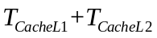=30ms
00:00:50:000 cachedataout 0 // after receiving the data, the data will be outputted immediately.
00:01:40:000 cacheaddressout 1
00:01:50:000 cachedataout 2
00:02:40:000 cacheaddressout 2
00:02:50:000 cachedataout 4
00:03:40:000 cacheaddressout 3
00:03:50:000 cachedataout 6
00:04:40:000 cacheaddressout 4
00:04:50:000 cachedataout 8
00:05:40:000 cacheaddressout 5
00:05:50:000 cachedataout 10
00:06:40:000 cacheaddressout 6
00:06:50:000 cachedataout 12
00:07:40:000 cacheaddressout 7
00:07:50:000 cachedataout 14
//
00:08:20:000 cachedataout 2 // hit cache L1, only use 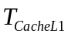=10ms
00:09:00:000 cachedataout 4 // hit cache L1, only use
00:09:40:000 cachedataout 0 // hit cache L1, use =30ms

Note
The replacement algorithm is not typically a LRU method, but it is easy to change this replacement algorithm. But there is no time. I want to point this out.

Atomic Model CentralProcessingUnit(CPU)：
The input of the CPU is a integer indicating how many memory accesses the CPU should issue. Then the CPU will issue memory accesses. After receiving the data and finishing an memory access, the CPU will prepare the next issue. The preparation time is a random value, whose distribution is normal with a mean value 3ms. When the data is not returned in time , an error will occur. The time here is 1s20ms.

The CentralProcessingUnit.ev file is created as follows.
00:00:10:00 ControlIn 4
00:00:20:00 DataIn 4
00:00:30:00 DataIn 5
00:00:40:00 DataIn 6
00:00:50:00 DataIn 7
00:00:60:00 DataIn 8

The output file CentralProcessingUnit.out shows the expected results.
00:00:12:987 addressout 10 // randomly generated addresses, issued after the preparation time
00:00:20:000 datareceived 4
00:00:21:796 addressout 27
00:00:30:000 datareceived 5
00:00:31:957 addressout 31
00:00:40:000 datareceived 6
00:00:43:035 addressout 6
00:00:50:000 datareceived 7

Coupled Model MH ：

The mh.ev file is created as follows.
00:00:10:00 ControlIn 32 // we issue 32 memory accesses

The mh.out file is created as follows.

00:00:12:987 addressout 8
00:01:22:987 datareceived 16 // both cache l1 and l2 misses, we need access the main memory, the time is 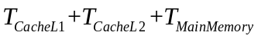=70ms
00:01:24:783 addressout 4 // both cache l1 and l2 misses
00:02:34:783 datareceived 8
00:02:36:740 addressout 23 // both cache l1 and l2 misses
00:03:46:740 datareceived 46
00:03:49:775 addressout 31 // both cache l1 and l2 misses
00:04:59:775 datareceived 62
00:05:01:957 addressout 25 // both cache l1 and l2 misses
00:06:11:957 datareceived 50
00:06:15:117 addressout 22 // both cache l1 and l2 misses
00:07:25:117 datareceived 44
00:07:28:966 addressout 8 // cache l1 miss
00:07:58:966 datareceived 16
00:08:02:621 addressout 0 // both cache l1 and l2 misses
00:09:12:621 datareceived 0
00:09:16:067 addressout 2 // both cache l1 and l2 misses
00:10:26:067 datareceived 4
00:10:28:897 addressout 4 // hit cache l1
00:10:38:897 datareceived 8
00:10:41:297 addressout 29 // both cache l1 and l2 misses
00:11:51:297 datareceived 58
00:11:54:984 addressout 2 // cache l1 miss
00:12:24:984 datareceived 4
00:12:26:039 addressout 28 // both cache l1 and l2 misses
00:13:36:039 datareceived 56
00:13:39:717 addressout 23 // hit cache l1
00:13:49:717 datareceived 46
00:13:53:396 addressout 23 // hit cache l1
00:14:03:396 datareceived 46
00:14:08:155 addressout 25 // cache l1 miss
00:14:38:155 datareceived 50
00:14:41:239 addressout 16 // both cache l1 and l2 misses
00:15:51:239 datareceived 32
00:15:53:772 addressout 31 // hit cache l1
00:16:03:772 datareceived 62
00:16:05:476 addressout 22 // hit cache l2
00:16:35:476 datareceived 44
00:16:37:895 addressout 8 // hit cache l2
00:17:07:895 datareceived 16
00:17:11:121 addressout 2 // hit cache l2
00:17:41:121 datareceived 4
00:17:45:989 addressout 3 // cache l2 and cache l1 miss
00:18:55:989 datareceived 6
00:18:58:715 addressout 9 // cache l2 and cache l1 miss
00:20:08:715 datareceived 18
00:20:13:337 addressout 5 // cache l2 and cache l1 miss
00:21:23:337 datareceived 10
00:21:25:719 addressout 25 // hit cache l2
00:21:55:719 datareceived 50
00:21:58:831 addressout 15 // cache l2 and cache l1 miss
00:23:08:831 datareceived 30
00:23:11:668 addressout 13 // cache l2 and cache l1 miss
00:24:21:668 datareceived 26
00:24:24:982 addressout 22 // hit cache l2
00:24:54:982 datareceived 44
00:24:56:481 addressout 5 // cache l2 and cache l1 miss
00:26:06:481 datareceived 10
00:26:09:709 addressout 26 // cache l2 and cache l1 miss
00:27:19:709 datareceived 52
00:27:23:245 addressout 24 // cache l2 and cache l1 miss
00:28:33:245 datareceived 48
00:28:37:234 addressout 8 // hit cache l2
00:29:07:234 datareceived 16
We can see that the MH simulator execute correctly as we expect.

